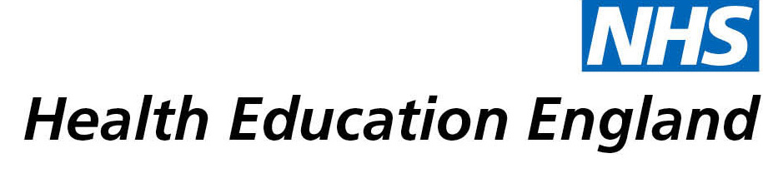

# Library and Knowledge Services case study

# *George Eliot Hospital NHS Trust William Harvey Library : Impact of current awareness and information skills training*

Date *20/5/21*

## Reason for enquiry

*I was studying for SLMDA- Senior Leadership Management Degree Apprenticeship- level 7 qualifications- degree, masters and apprenticeship. My dissertation topic looked at the wellbeing of staff within a hospital setting - particularly GEH- during a pandemic. I used the Library Services throughout my course, in particular:*

* *Attending group training sessions- referencing skills and literature searching*
* *Accessed current awareness service via KnowledgeShare*
* *1:1 sessions for bespoke literature searching support*

## What the knowledge and library specialist did

* *Taught training sessions on literature searching and referencing*
* *Provided personalised 1:1 advanced literature searching teaching sessions*
* *Provided an individualised current awareness service via KnowledgeShare*
* *Used expertise to suggest how to both focus and expand my literature searching horizons, which was particularly necessary when researching the cutting edge and niche topic of my dissertation.*

# Impact of input from the library and knowledge service

*Current awareness fed directly into my apprenticeship and relating theory to practice. The apprenticeship is 20% work based. Alongside the theory gained from the masters course, I used the current awareness research to apply theory to practice and strategic thinking in my Trust.*

*What I found really valuable were things that I didn’t know existed, so I didn’t know to ask for them. As the Librarian did the individual sessions, they understood where I was trying to get to. The Librarian helped me to identify new sources of information and platforms to search, as well as areas to develop my dissertation. That speciality knowledge is important- by listening to me the librarian identified what I was actually asking for without knowing it. She gave me the right questions to ask.*

*In terms of current awareness, being able to target my interests, and utilising the clinical librarian’s ability to focus my requirements as the pandemic and my research progressed, kept my research results current.*

## Immediate Impact

*Using current research to inform strategic push through to guidelines and practice in the work place. The impact has been on my studies, but also to my contribution to the wider team and strategic decisions made at a board level within the Trust. The research enabled me to move from decision making to strategic planning, and influence this type of thinking within the Trust as a whole. The immediate nature of my research necessitated an evolving search strategy as the landscape of my dissertation topic changed.*

*A direct example of the literature searching sessions and current awareness impacting on events in the Trust during the pandemic is the ongoing campaign to ensure that staff are aware of wellbeing initiatives. Prior to January 2021 a number of wellbeing initiatives aimed at staff were in place, but a survey showed that staff were unaware of the breadth of support available to them. Evidence from literature searches and current awareness informed my report to a relevant trust board where I fed back strong, current research findings that wellbeing strategies needed to be highlighted and magnified to acknowledge staff need, and inform staff of the wellbeing and welfare opportunities open to them. It became a priority for the Trust to find new platforms to ensure staff are engaged with available wellbeing initiatives.*

## Probable future Impact

*What I now know and understand is that as I need more information to develop planning, ideas and strategies, I can get this service from the Library. By developing a collaborative relationship with the library, I am able to be evidence based throughout my future career. Ultimately this will have a massive impact on patient safety. The ripple effect of having a positive experience with accessing library services is that I have had the confidence in the library to enable my development of skills which will continue inform my practice in the future.*

## Submission by:

*Rosemary Musanhu-Senior Research Nurse*

## For further information on how you can get similar support contact your local NHS library and knowledge service.